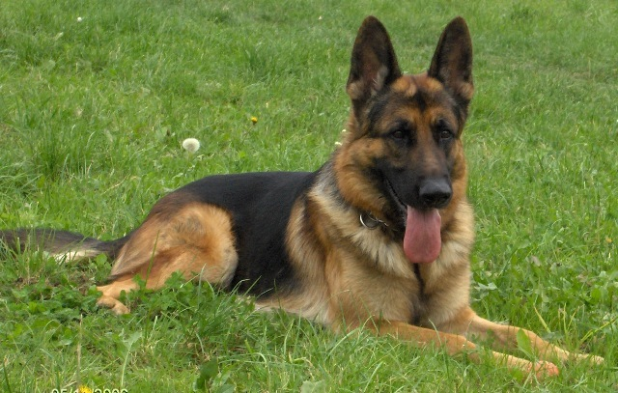
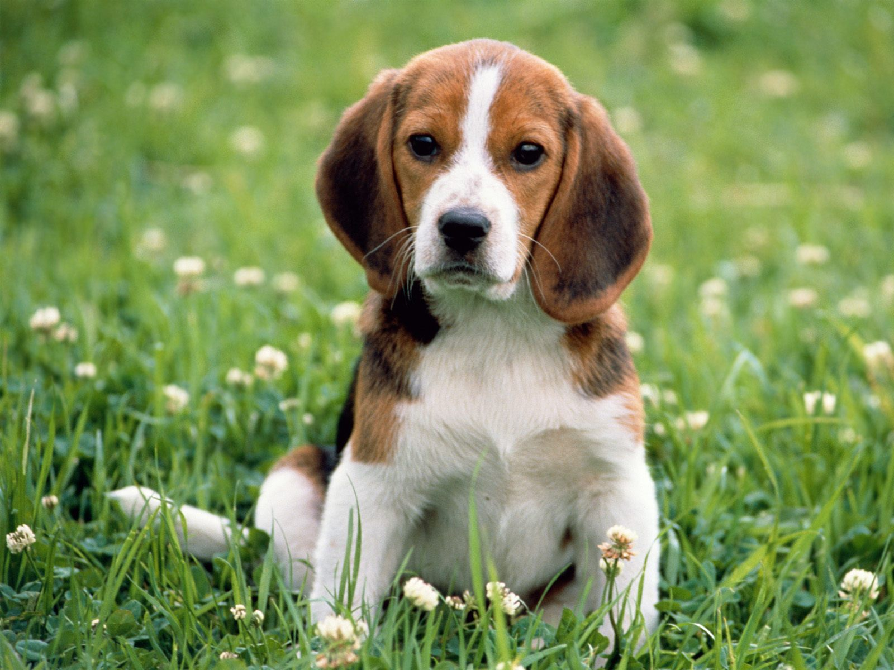

COMPANION & FUN
DOG SHOW

Kemsley Village Hall, Ridham Avenue, Kemsley,
Nr. Sittingbourne, Kent, ME10 2SF
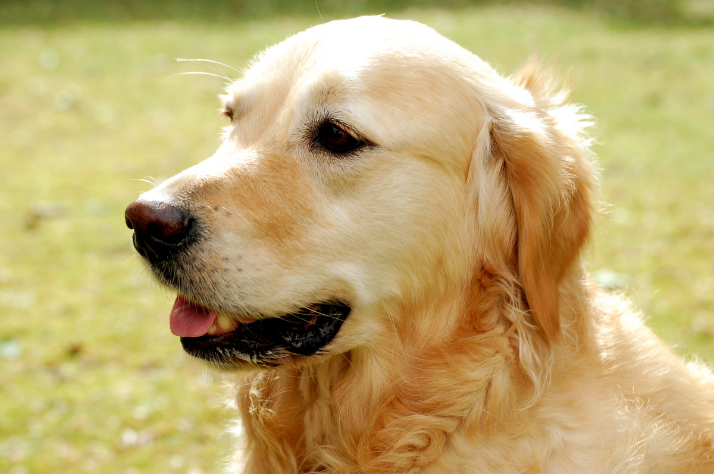
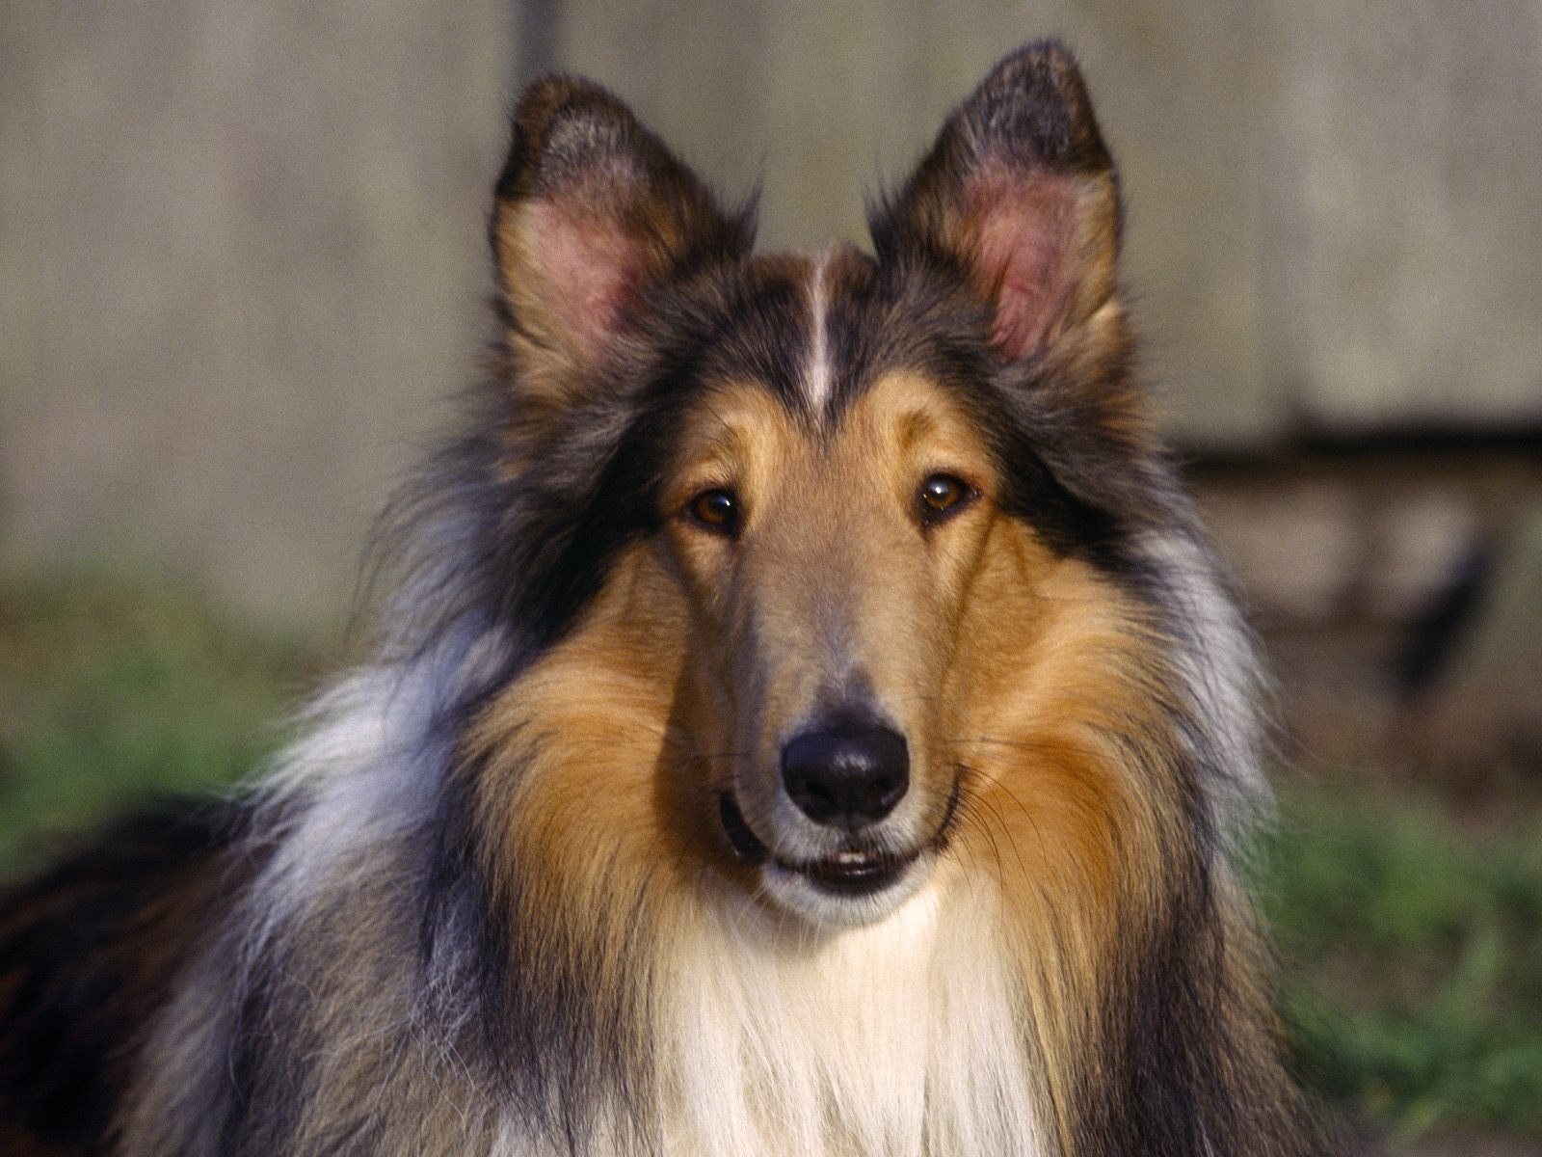
On Saturday November 12th 2022
Donation from proceeds to Kent Air Ambulance

(Held under Kennel Club Rules & Regulations)
Booking in from 10.00 am and Judging from 11.00 am

Pedigree Classes £2.00 per class - Rosettes to 6th place - 11.00am start - Judged by: Alison Harper

1. AV Puppy (6-12 Months ) | 6. AV Toy & Utility
2. AV Junior (12-18 Months) | 7. AV Working & Pastoral
3. AV Terrier | 8. AV Open
4. AV Gundog | Best Pedigree in Show
5. AV Hound
Novelty Classes £2.00 per class-Rosettes to 6th place - not before: 1pm - Judged by: Alison Harper

9. Best Crossbreed | 18. Prettiest Bitch
10. Best Long Coat | 19. Dog Judge would most like to take home
11. Best Short Coat | 20. Most Appealing Eyes
12. Best Rescue | 21. Young Handler (16 & under)
13. Senior Handler (over 16) | 22. Foreign breed
14. Best Veteran (over 7 Years) | 23. Best Brace (any two dogs)
15. Dog with The Waggiest Tail | 24. Best 6 legs
16. Best Condition | 25. Best pair of rear ends
17. Handsomest Dog | Best Novelty In Show
DOGS WHICH HAVE WON ANY OF THE FOLLOWING AWARDS ARE NOT ELIGIBLE FOR ENTRY AT COMPANION DOG SHOWS:
• Challenge Certificate (or any award that counts towards the title of Champion under the rules of any governing body
recognised by the Kennel Club). (Pedigree classes only).
• Reserve Challenge Certificates. (Pedigree classes only).
• Junior Warrant. (Pedigree classes only).
The Kennel Club would like to thank Faversham & District Riding Club for organising this show on its behalf.

There will be a table top sale of dog & horse equipment during the day. Items must be labelled with the seller’s name & price required. Cash Only
For Further Details on the show or sale please Phone: 07979432818

DOGS IN CARS ON HOT DAYS - Your dog is vulnerable and at risk during hot weather and the Kennel Club offers the following guidance to help guide you through the do’s and don’ts travelling to and whilst at Kennel Club licensed events.
• When travelling to a show please take a moment to consider whether the route to the show is on a busy holiday route, and leave earlier to avoid increased time in traffic jams.
• If your vehicle is not air-conditioned seriously consider whether, travelling to the show is a good idea at all.
• The vehicle should be as fully ventilated as possible, and plenty of stops should be taken, with lots of water available to drink.
• Ensure your dog is not sitting in full sunlight. There should be plenty of free flowing air around the dog.
• When at the show, never leave your dog in the vehicle.
• Keep the dog in the shade – take your own shade, for example a large umbrella and always have plenty of water available to drink so your dog stays well hydrated.
• Avoid your dog taking part in unnecessary exertion, or from standing in exposed sunlight for extended lengths of time. Remember, if you feel hot your dog is very likely to feel much hotter and dehydrated, and this could lead to dire results. Please look after your dog’s welfare.
Warning: if your dog is found to be at risk, forcible entry to your vehicle may be necessary without liability for any damage caused.
Anyone whose dog is entered at a Kennel Club licensed event should take all reasonable steps to ensure the needs of their dog(s) are met, and should not put a dog’s health and welfare at risk by any action, default, omission or otherwise.
Breach of Kennel Club Regulations in this respect may be referred to the General Committee for disciplinary action under Kennel Club Regulations.
Hand sanitisers will be available for use.

