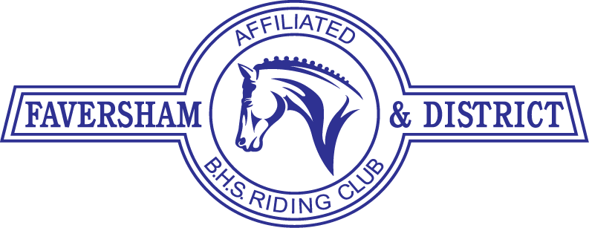
For Official Use Only
J/S E/M BHS

BAC / CHQ Rcd
FDRC
MEMBERSHIP
FORM
(Mr/ Mrs/Miss/Ms)
Name

Address

Post Code Tel. Number Mobile

E-mail
Senior Members must be 17 or over on January 1st of the current year
Junior Members must be under 17 on Jan 1st of the current year – Minimum age 8 yrs

DOB if 16 & under:

Please fill in Membership & Payment options. |  | Please tick / delete as appropriate | MARK X
FULL MEMBER - £32.50 | £ | I am a Rider and/or Horse Owner | Owner
FAMILY MEMBER - £20.00 *see footnote | £ |  | Rider
NON-RIDING MEMBER - £20.00 | £ | I can help at FDRC Events | Ridden
EXTENDED MEMBERSHIP – If joining after Oct 1st of current year you may add £5.00 to the above fee & join until Dec 31st the following year. | £ |  | Social
 |  | I would like to compete in FDRC Teams
I am paying by cheque & posting |  | I am paying by BACS & attaching confirmation of payment to my email

PAYMENT: Payment can be made by cheque made out to Faversham & District Riding Club & posted or paid by BACS to Account Number : 30858356 Sort Code: 60 19 25 Ref: Membership
Forms & Bacs confirmation must be & emailed to faversham.rc@gmail.com
PRIVACY : Personal information that you supply to us may be used in a number of ways to facilitate your riding club membership. We are affiliated to the British Horse Society as a British Riding Club, your personal data for the purpose of fulfilling your full membership benefits i.e. insurance providers. We / BRC will automatically contact you about your membership: for example, to ensure you receive your membership benefits, to tell you about news, activities and events. This includes sending you a regular magazine, Club newsletter, email updates, information on other membership benefits, and publishing competition times and results in the public domain. To see our full Privacy Policy, or if you need any further information, please write to us at: Membership Sec, Bolton Farmhouse, Rose Lane, Lenham Heath, Maidstone ME17 2JN or go to: www.favershamridingclub.com/privacy-statement
I DO CONSENT |  | I DO NOT CONSENT

By signing & sending this form to Faversham & District Riding Club You are agreeing to abide by the rules and regulations of the said Club which can be found at https://www.favershamridingclub.com/useful-links
SIGNED............................................................................................ DATE ...............................................
Name of Parent/Guardian if 16 yrs. or under......................................................................................................
Membership of the FDRC is renewable on January 1st each year.
Please return completed form, monies or notification of BACS payment to: Sally King, Bolton Farmhouse,
Rose Lane, Lenham Heath, Maidstone, Kent ME17 2JN or email to: faversham.rc@gmail.com

FAMILY MEMBERSHIP: Each Family Member must have one FULL MEMBER residing at the same address. There is no restriction on number of FAMILY MEMBERS per household but each one must fill in a separate Membership Form. FAMILY MEMBERS have the same rights as Full Members except that they are not allowed to serve on the Committee or vote at the A.G.M.

